Published 09/04/2020 – with an update about how clients can download and use the application on their phone for hearings.
02/04/2020 – with an update about how to combine with Clickshare, and how to answer calls from the court if necessary.

How to – Skype for Business: Remote Working on the Western Circuit
This product is the product that the courts currently intend to use for most video hearings.

Skype for Business (S4B) Licenses
Some Chambers and practitioners already have licenses for Skype for Business. If you do not, you can no longer purchase one, as S4B is being phased out. The courts, however, do have a license.
You DO NOT need a license to participate in a S4B hearing or conference.

The App
You do not need to download an application to access the calls, but it is easier if you do. There appear to be a number of apps you can use. This guide uses the Skype Meetings App. If you are using an Apple product, you will probably need to download the Skype for Business App. :
- It will be easiest if you download the app in advance; just search for “Download Skype Meetings App” or “Download Skype for Business App”. It is also possible to download an App using the invitation you receive – this has not always worked for Windows users so, if in doubt, search for the app online.
- Make sure to download the App in advance to save rushing before the hearing. If you want to use the link in the invitation, you can do this as soon as you receive the invitation – it is the same link to join the call, and you can use the link in advance to download the app.
- You will need to “run” the programme and accept the messages it asks you during the installation process.

The Hearings
As the courts have the license, they will be “hosting” the meeting.
- You will receive an invitation email – click “accept”. Some courts are sending them days in advance, others are sending this moments before the hearing.
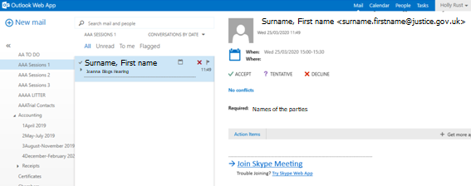
- The hearing will appear in your calendar; this is the S4B meeting request. You can find your calendar by going into your emails, and clicking “Calendar”:

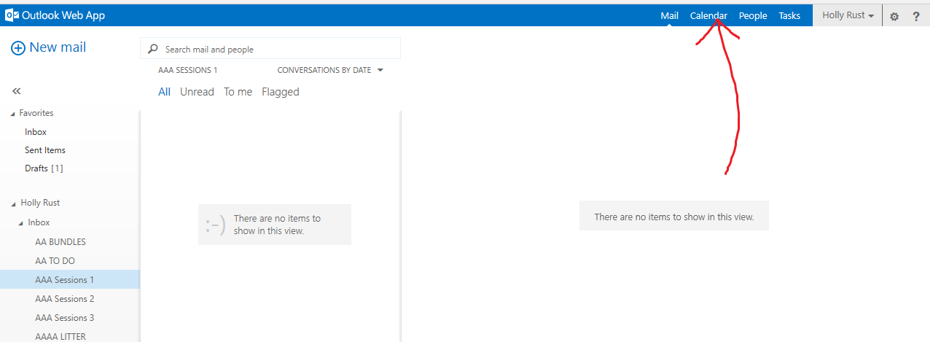
- When you are ready for your hearing, go to your calendar, and click on the hearing/meeting request:
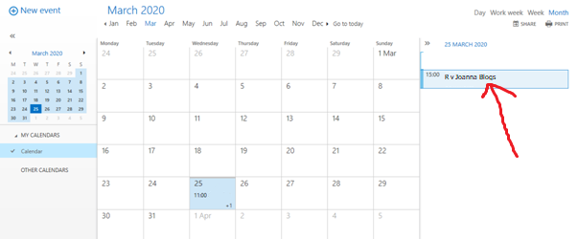
- Then click to join the meeting:
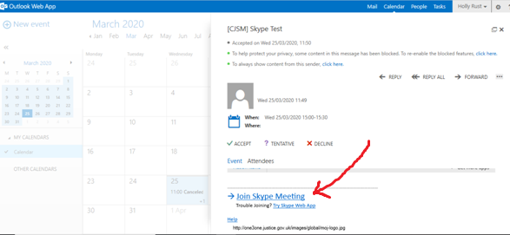
- This should give you the option to open it in your chosen app. You will need to type your name in to join as a “Guest”. This does not need to be your email address, but the name you want the court to see.
- This screen (or a similar screen, depending on your chosen app/operating system) will open (if you are the first participant, it will say “Looks like you’re the only one in the meeting” - just wait for others to join):
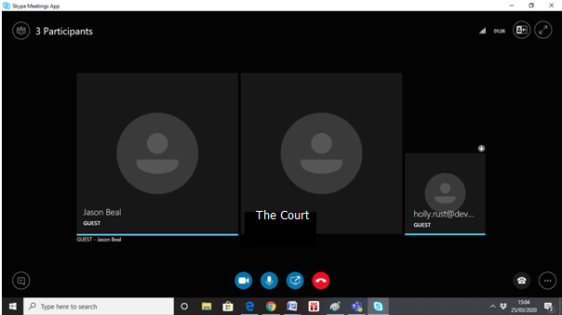

- You will need to enable your own video and audio for the videocall. For video, click on the camera, then click on “Start My Video”:
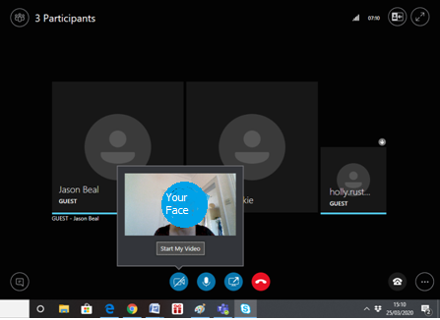
One you have clicked “Start My Video”, your video will appear above your name.
- You will need to turn on your audio by pushing the microphone button:
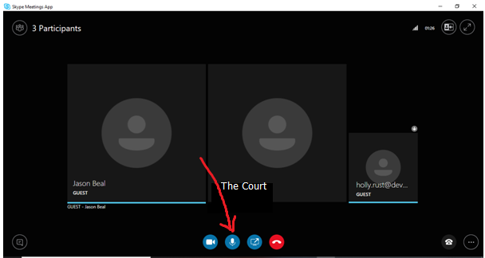

- To end the call, push the red phone:
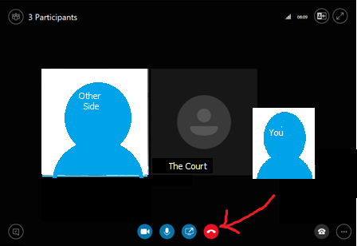

Combining Skype for Business with Clickshare to see Defendants
The Crown Court at Nottingham have created a work-around to enable defendants to see and hear what other parties can see:
- The court arranges a Skype for Business meeting for the hearing.
- The legal representatives and the judge join the Skype for Business hearing.
- The court clerk connects to the prison video link (as usual).
- The court clerk combines the two using click-share.
- The court clerk can turn their camera to the click-share screen to show the defendant.
This enables the defendant to see and hear all parties.
If the judge is using their own camera, then all parties can see each other at all times. If the judge is using the clerk’s camera, then they will not be visible when the camera is showing the defendant. It is suggested that the defendant appear during arraignment etc, and that the judge appear whilst advocates are addressing the court.

Non-Custody Defendants
Non-custody defendants can attend hearings in the same way, if they have access to a computer or to a smart phone.
To access hearing using their computer, clients can be provided with the instructions as above to download the programmes and access the hearings.
If using their mobile phone, they will need to download the application:

Download instructions: Android Phones
- The client will need to download the Skype for Business application. They can either search for this in the Play Store, or use the meeting link sent in the invitation email. As with computers, it helps to download the application prior to the hearing.
- The application to download is the “Skype for Business for Android/Microsoft Organisation”. They should press “install”
- When installed, they can either use the “open” button on the Play Store screen, or find the application on their phone and tap it (as with any other application).
- The application asks for permission to access photos, phone calls, audio, etc. The client will need to select “allow” for each of these. The client will also need to “Accept” the terms of use.
- The phone will display a message, stating that you need a Skype for Business account. This can be ignored (you do not need an account). Press the arrow to move forward.
- They will be asked for their account details. This should also be ignored (unless they have an account already).
- The application is now downloaded and ready to be used, and so the application can be closed until it is needed.

iPhones
- The client will need to download the Skype for Business application. They can either search for this in the App Store, or use the meeting link sent in the invitation email. As with computers, it helps to download the application prior to the hearing.
- The correct application to install is “Skype for Business”.
- During installation, he application asks for permission to access photos, phone calls, audio, etc. The client will need to select “allow” for each of these. The client will also need to “Accept” the terms of use.
- The client will be asked for their account details. This should also be ignored (unless they have an account already).
- The application is now downloaded and ready to be used, and so the application can be closed until it is needed.

Joining the Hearing
- The client should be sent the meeting link/invitation, in the same way the advocates are. If the court does not send it to the client, the advocate/solicitor can copy and paste their own meeting link into an email to the client. (Attempts to forward the email may be unsuccessful).
- The client should click the link in time for the start of the hearing.
- The S4B application will load. The client should select “Join as Guest” (NOT “sign in”).
- The client will be invited to enter their name, using their phone’s keyboard. This is the name that will appear on the screen during the hearing. They should then press
- The application will then connect the client to the meeting.
- As with the computer version, the client will need to select the video camera button and the microphone symbols to enable their video and audio.
- To leave the hearing, there is a red phone button to press.

Supporting Each Other
This is a new way of working for most of us. Please:
- Circulate a list amongst Chambers of people who are confident using Skype for Business, so that they can support others.
- If no one in Chambers can help, please contact the following members of circuit who now comprise the Covid-19 IT Committee:
Elizabeth Bowden: ebowden@college-chambers.co.uk
Holly Rust: holly.rust@devonchambers.co.uk
Piers Norsworthy: piers.norsworthy@devonchambers.co.uk
- Any tips – let us and others know!

